JAVA PROGRAMMING ASSIGNMENT

Experiment – 2

Name : Yash Saxena

Roll no. : 12213128

Branch : IT B(07)

Que-1

Code :

import java.util.Scanner;

public class Que_1{

    public static void compare_string(String a, String b){

        System.out.println("The result of a == b is " + (a==b));

        System.out.println("The result of a != b is " + (a!=b));

        System.out.println("The result of a.equals(b) is " + a.equals(b));

    }

    public static void main(String args[]){

        Scanner sc = new Scanner(System.in);

        System.out.println("Enter the first string :-");

        String a = sc.next();

        System.out.println("Enter the second string :-");

        String b = sc.next();

        compare_string(a, b);

        sc.close();

    }

}

Output :

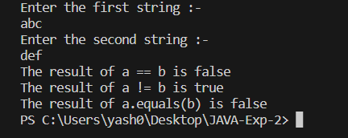

Que-2

Code :

class Dog {

    String name;

    String say;

    public Dog(String a, String b) {

        name = a;

        say = b;

    }

    public void info() {

        System.out.println("The name of the dog is " + name + " and it says " + say);

    }

}

public class Que_2 {

    public static void main(String args[]) {

        Dog a = new Dog("Spot", "Ruff!");

        Dog b = new Dog("Scruffy", "Wurf!");

        a.info();

        b.info();

        // creating a new dog reference and assign it to spot's object.

        Dog c = b;

        // Testing === and equals for all references.

        System.out.println("The result of a==b is " + String.valueOf(a==b));

        System.out.println("The result of b==c is " + String.valueOf(b==c));

        System.out.println("The result of c==a is " + String.valueOf(c==a));

        System.out.println("The result of a.equals(b) is " + a.equals(b));

        System.out.println("The result of b.equals(c) is " + b.equals(c));

        System.out.println("The result of c.equals(a) is " + c.equals(a));

    }

}

Output :

